Joins Contd
______________________________________________________________________________
Problem Statement:
You are a Data Analyst at Amazon Fresh. You have been tasked to study the Farmer’s Market.

Dataset: Farmer’s Market database
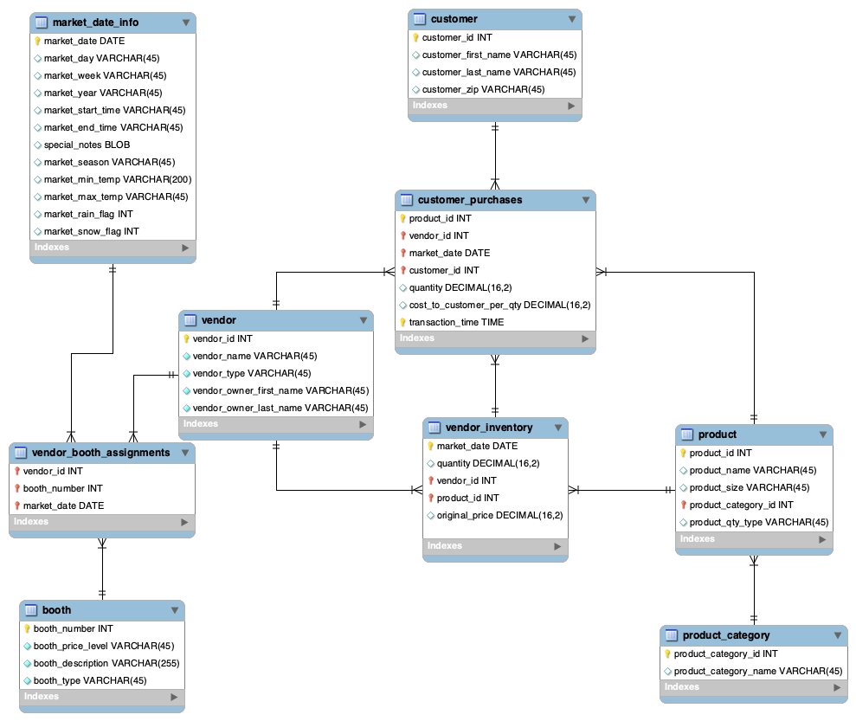
______________________________________________________________________________

JOINs with more than two tables -

Question: Let’s say we want details about all farmer’s market booths and every vendor booth assignment for every market date.

Imagine that you’re building an interactive report that lets you filter to a booth, a vendor, or a date, to see the resulting list of booth assignments with additional booth and vendor details.

So we need a merged dataset that contains all of their records.

This requires joining the three tables:
- booth
- vendor_booth_assignment
- vendor

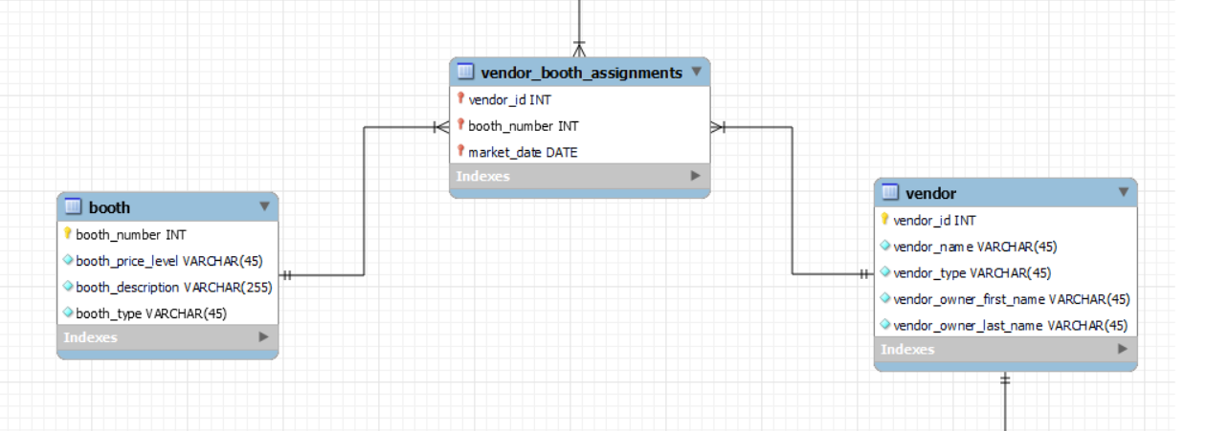

What kind of JOINs do you think we could use to ensure that all booths are included, even if they aren’t assigned to a vendor yet, and all vendors assigned to booths are included?

- We can LEFT JOIN the booth table to the vendor_booth_assignments, including all of the booths, and LEFT JOIN vendor to vendor_booth_assignments in the results.

The query to accomplish these joins looks like this -

SELECT
b.booth_number, b.booth_type,
vba.market_date,
v.vendor_id, v.vendor_name, v.vendor_type
FROM farmers_market.booth AS b
LEFT JOIN farmers_market.vendor_booth_assignments AS vba
ON b.booth_number = vba.booth_number
LEFT JOIN farmers_market.vendor AS v
ON v.vendor_id = vba.vendor_id
ORDER BY b.booth_number, vba.market_date;

- You can think of the second JOIN as being merged into the result of the first JOIN.
- Because in this case the vendor_id field in the third table, vendor, is joined to the vendor_id field in the second table, vendor_booth_assignments, only vendors that exist in the vendor_booth_assignments table will be included, resembling something like this:

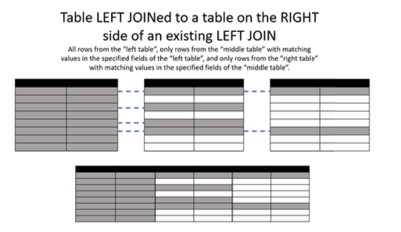

____________________________________________________________________________

Question: For each employee in the given table, find out the name of their manager.

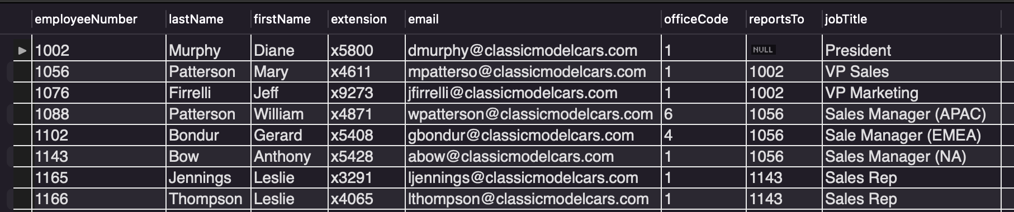

Here, we have the employee table in which for every employee we have the ‘reportsTo’ column where the employee ID of the manager is recorded.

Now, how would you solve this problem?

Note: For Murphy, we have NULL in reportsTo, so he must be the TOP manager/CEO.

Self JOIN

Query:
SELECT
CONCAT(e.lastName, ' ', e.firstName) AS Employee
CONCAT(m.lastName, ' ', m.firstName) AS Manager,
FROM
employees e
JOIN employees m
ON m.employeeNumber = e.reportsTo
ORDER BY Manager;

____________________________________________________________________________

Cross JOIN

A Cross JOIN, also known as the Cartesian JOIN basically matches each record from one table (say T1) with each record from the other table (say T2).

So if we have ‘n’ no. of rows in T1 and ‘m’ no. of rows in T2 then the resulting table (say T3) will have ‘nxm’ no. of rows.

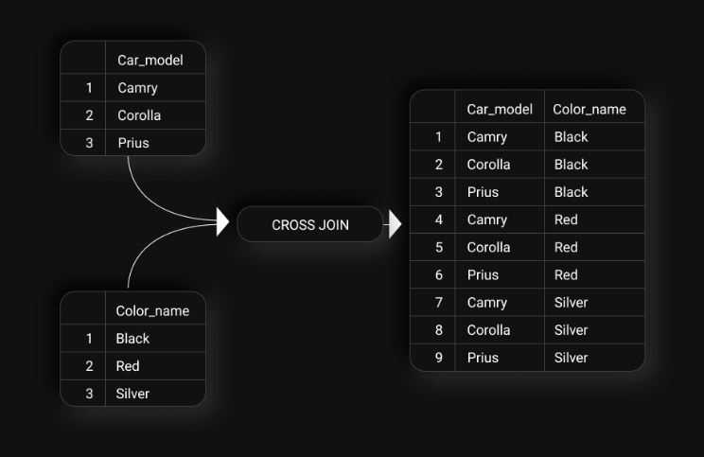

Query:
SELECT
c.Car_model,
c1.Color_name
FROM Cars c
CROSS JOIN Colors c1;

OR

SELECT
c.Car_model,
c1.Color_name
FROM Cars c, Colors c1;

Another example of Cross JOINs could be: You want to calculate the total sales of a product in every store in a country. For every product, we’d need to create a combination of product and store mapping.

Thus, we’d need to use cross-join for that.

____________________________________________________________________________

Equi & Non-equi Joins
We have seen equi-joins which are the regular joins.

- Non-equi Join is also a type of Join in which we need to retrieve data from multiple tables.
- Non-Equi Join matches the column values from different tables based on an inequality based on the operators like, <,>,<=,>=,!=, BETWEEN, etc.

Given the User table and the Country table.

We have data of several users, the countries they can visit and the countries they’ve already visited.

User table -
user | country_visited
John | India
Susan | USA
Mark | Japan

Country table -
travel_to
India
USA
Japan

Question: Recommend new countries to the users which they have not visited yet.

Query:
SELECT *
FROM dataset.User T1
JOIN dataset.Country T2
ON T1.country_visited <> T2.travel_to

Output:
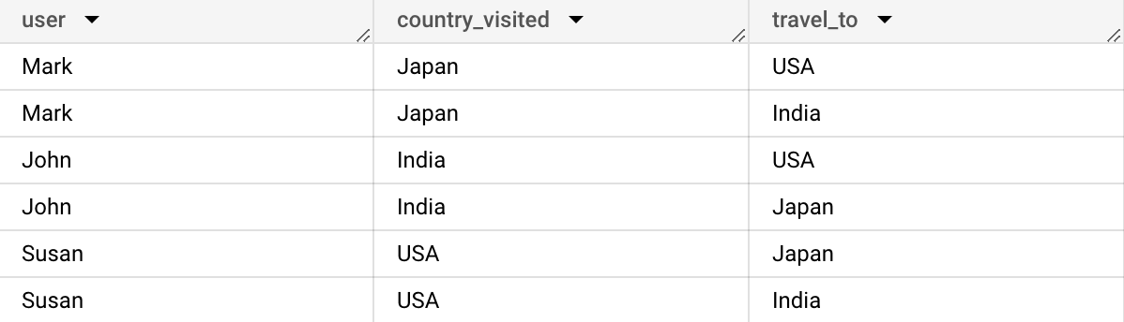

Given the Kids_info table and the Toys_info table.

Kids_info table-
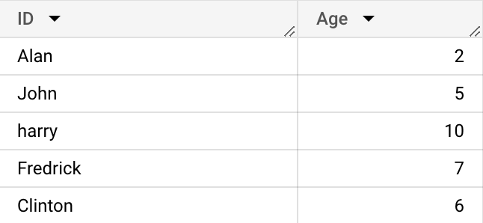

Toys_info table -
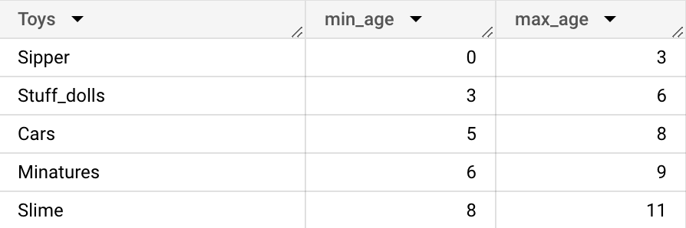

Question: Recommend toys to each kid who is above the minimum required age to play with those toys.

Query:
SELECT *
FROM dataset.Toys_info T
JOIN dataset.Kids_info K
ON K.Age >= T.min_age

Output:
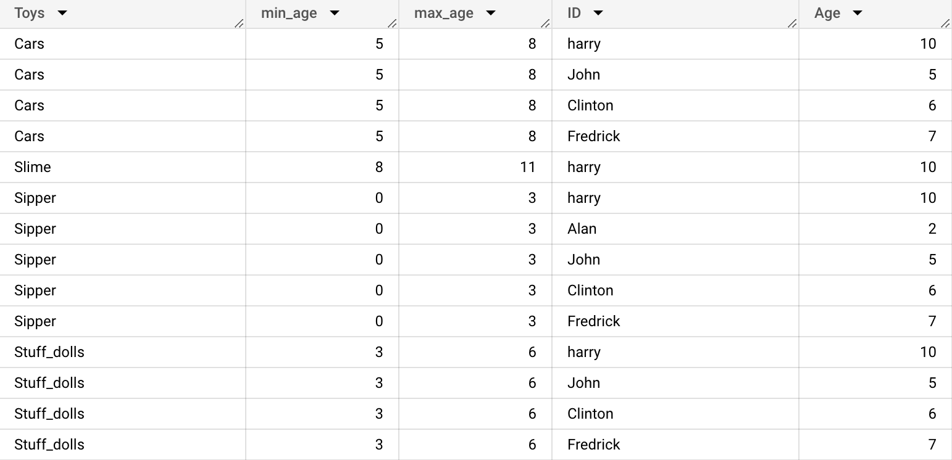

Question: Recommend toys to each kid who falls within the right age group to play with those toys.

Query:
SELECT *
FROM dataset.Toys_info T
Join dataset.Kids_info K
ON K.Age BETWEEN T.min_age AND T.max_age

Output:




